# Qualification Form – Current problems

#1) The (?) help content, found in the Screen table in the immigration database are missing.

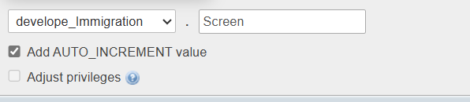

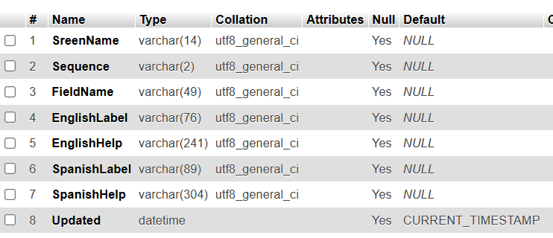

#2) All date masks need to be change to mm/dd/yy

#3) Add “Logout” button. Anash, what do you think, Top? Bottom? Both?

#4) Add short test videos to the app.

#5) Change section title from “Others” to “Additional Considerations”

#6) We need a good design for the 3 fields that current have both a checkbox and pulldown. The issue is that most people don’t have these issue, but if they might have them, they need to see a list.

#7) Since this form is so long, we need to be judicious with the spacing.